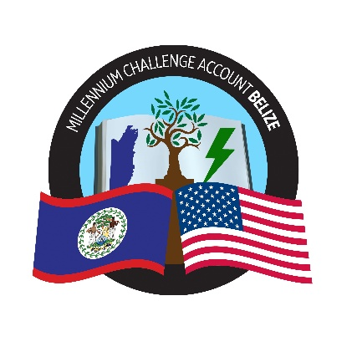

GENERAL PROCUREMENT NOTICE (GPN)

Government of the State of Belize

Millennium Challenge Account - Belize

GPN Version: 2026-4

GPN Publication Date: 15 September 2026

The United States of America, acting through the Millennium Challenge Corporation (“MCC”) and the State of Belize (Belize) have entered into an Millennium Challenge Compact “Agreement” to help facilitate poverty reduction through economic growth in Belize in the amount not to exceed One Hundred Fourteen Million Three Hundred Thirty-Eight Thousand Dollars of the United States of America (US$114,338,000) (“Program Funding”) to implement the Program and in addition to the Program Funding, an amount not to exceed Ten Million Six Hundred Sixty-Two Thousand Dollars of the United States of America (US$10,662,000) to facilitate implementation of this Agreement, and a corresponding contribution from Belize of no less than Forty Million Six Hundred Fifty Thousand Dollars of the United States of America (US$40,650,000).

The Government of Belize has designated the Millennium Challenge Account – Belize “MCA-Belize” to implement the Government’s responsibilities under the Agreement and intends to apply part of the funds for payments for contracts for Goods and Services.

The procurement program for the 12 months period from October 2026 to September 2027 will include the following:

Procurements for October 2026 to September 2027
Estimated Value –USD 50,077,263
Procurement of Goods to include:
- IT equipment for MCA-B MIS Infrastructure
- Vehicle tracking system for MCA-B Vehicles
- Office Supplies and Stationery for MCA-Belize
- Delivery of Health and Safety Supplies for MCA-Belize
- Procurement of Shredders for MCAs office space
Procurement of Works:
- Design, Procure and Install San Pedro Ambergris Caye Submarine Cable
Procurement of Consultant Services:
- Finance Short Term Surge Support
- Technical Evaluation Panel (TEP) Members
- Consultant to assist HR Manager with duties over 24 months
- Legal Counsel - FIDIC Contract Expert
- Consultancy for Development of Employer's Requirements (Surge support - individual to be selected from MCC's master list)
- Consultancy for Employer's Representative
Procurement of Non-consultant Services:
- Rental of conference/meeting room.
- Insurance Coverage for office contents
- Vehicle maintenance services for MCA-B Vehicles
- NSAS Storage and Transportation Materials
- Marketing & Outreach Event
- Provision of Catering and Logistical Support Services for MCA-Belize Board Meetings
- Local Transportation for MCA/MCC Implementation Event

Updated GPNs shall be published as new procurements are added.

Contracts for Goods, Works and Services financed under the program will be implemented according to the principles, rules and procedures set out in the MCC Procurement Policy and Guidelines (PPG) which can be accessed on www.mcc.gov/ppg. The Procurement is open to all offerors from eligible source countries as defined in the MCC PPG.

Specific procurement notices for contracts to be tendered under competitive bidding procedures will be announced, as they become available, on MCA-Belize website (https://mcabelize.bz/), Development Gateway Market (dgMarket: http://www.dgmarket.com/), Development Aid (https://www.developmentaid.org/), in local newspapers, and other media outlets as appropriate.

Interested eligible offerors who wish to be included on the mailing list to receive copies of procurement advertisements, or who require additional information, should complete the online form available at https://forms.cloud.microsoft/e/SKf5bPyiyv?origin=lprLink and indicate the procurement item(s) of interest.

